**Exercise 1: Setup Virtual Sandbox**

**Student Name: Student Id:**

**Date:**

Please use the screenshots ONLY as a reference. The written instructions have to be followed AS written.

PLEASE MAKE SURE YOU SUBMIT ALL THE SCREENSHOTS WITH TIMESTAMPS AT THE BOTTOM RIGHT (WINDOWS USERS) OR THE TOP RIGHT (MAC OSX USERS) OR ELSE YOU WILL AUTOMATICALLY QUALIFY FOR A DISCOUNT.

# Objective:

*The goal of this assignment is to help the student install all the tools necessary to setup the Cloudera Quick Start VM and familiarize the student with basic navigation.*

This assignment has 3 parts, all the steps have been described in detail. Please follow the steps and additional tips provided throughout the course while using the Cloudera VM.

**NOTE:**

* **Code to be executed is highlighted in Green**
* **The explanation for all the code is provided below the code**

Table of Contents

Objective: 1

Part 1: VMware Workstation Player: 3

Part 2: Cloudera VM: 14

Part 3: Navigation: 20

ADDITIONAL NOTES: 30

**NOTE: If you are using a Mac, please follow the steps in Mac Boot Camp Setup Guide before proceeding with this assignment.**

Part 1: VMware Workstation Player: This section covers setup of the VMWare Workstation Player.

Step-1: Go to the following link and download the VMware Workstation Player:

<https://my.vmware.com/en/web/vmware/free#desktop_end_user_computing/vmware_workstation_player/14_0|PLAYER-1415|product_downloads>

You will not need to fill out any details. Make sure you use the drop-down box shown below to select Major Version 14 not 15.

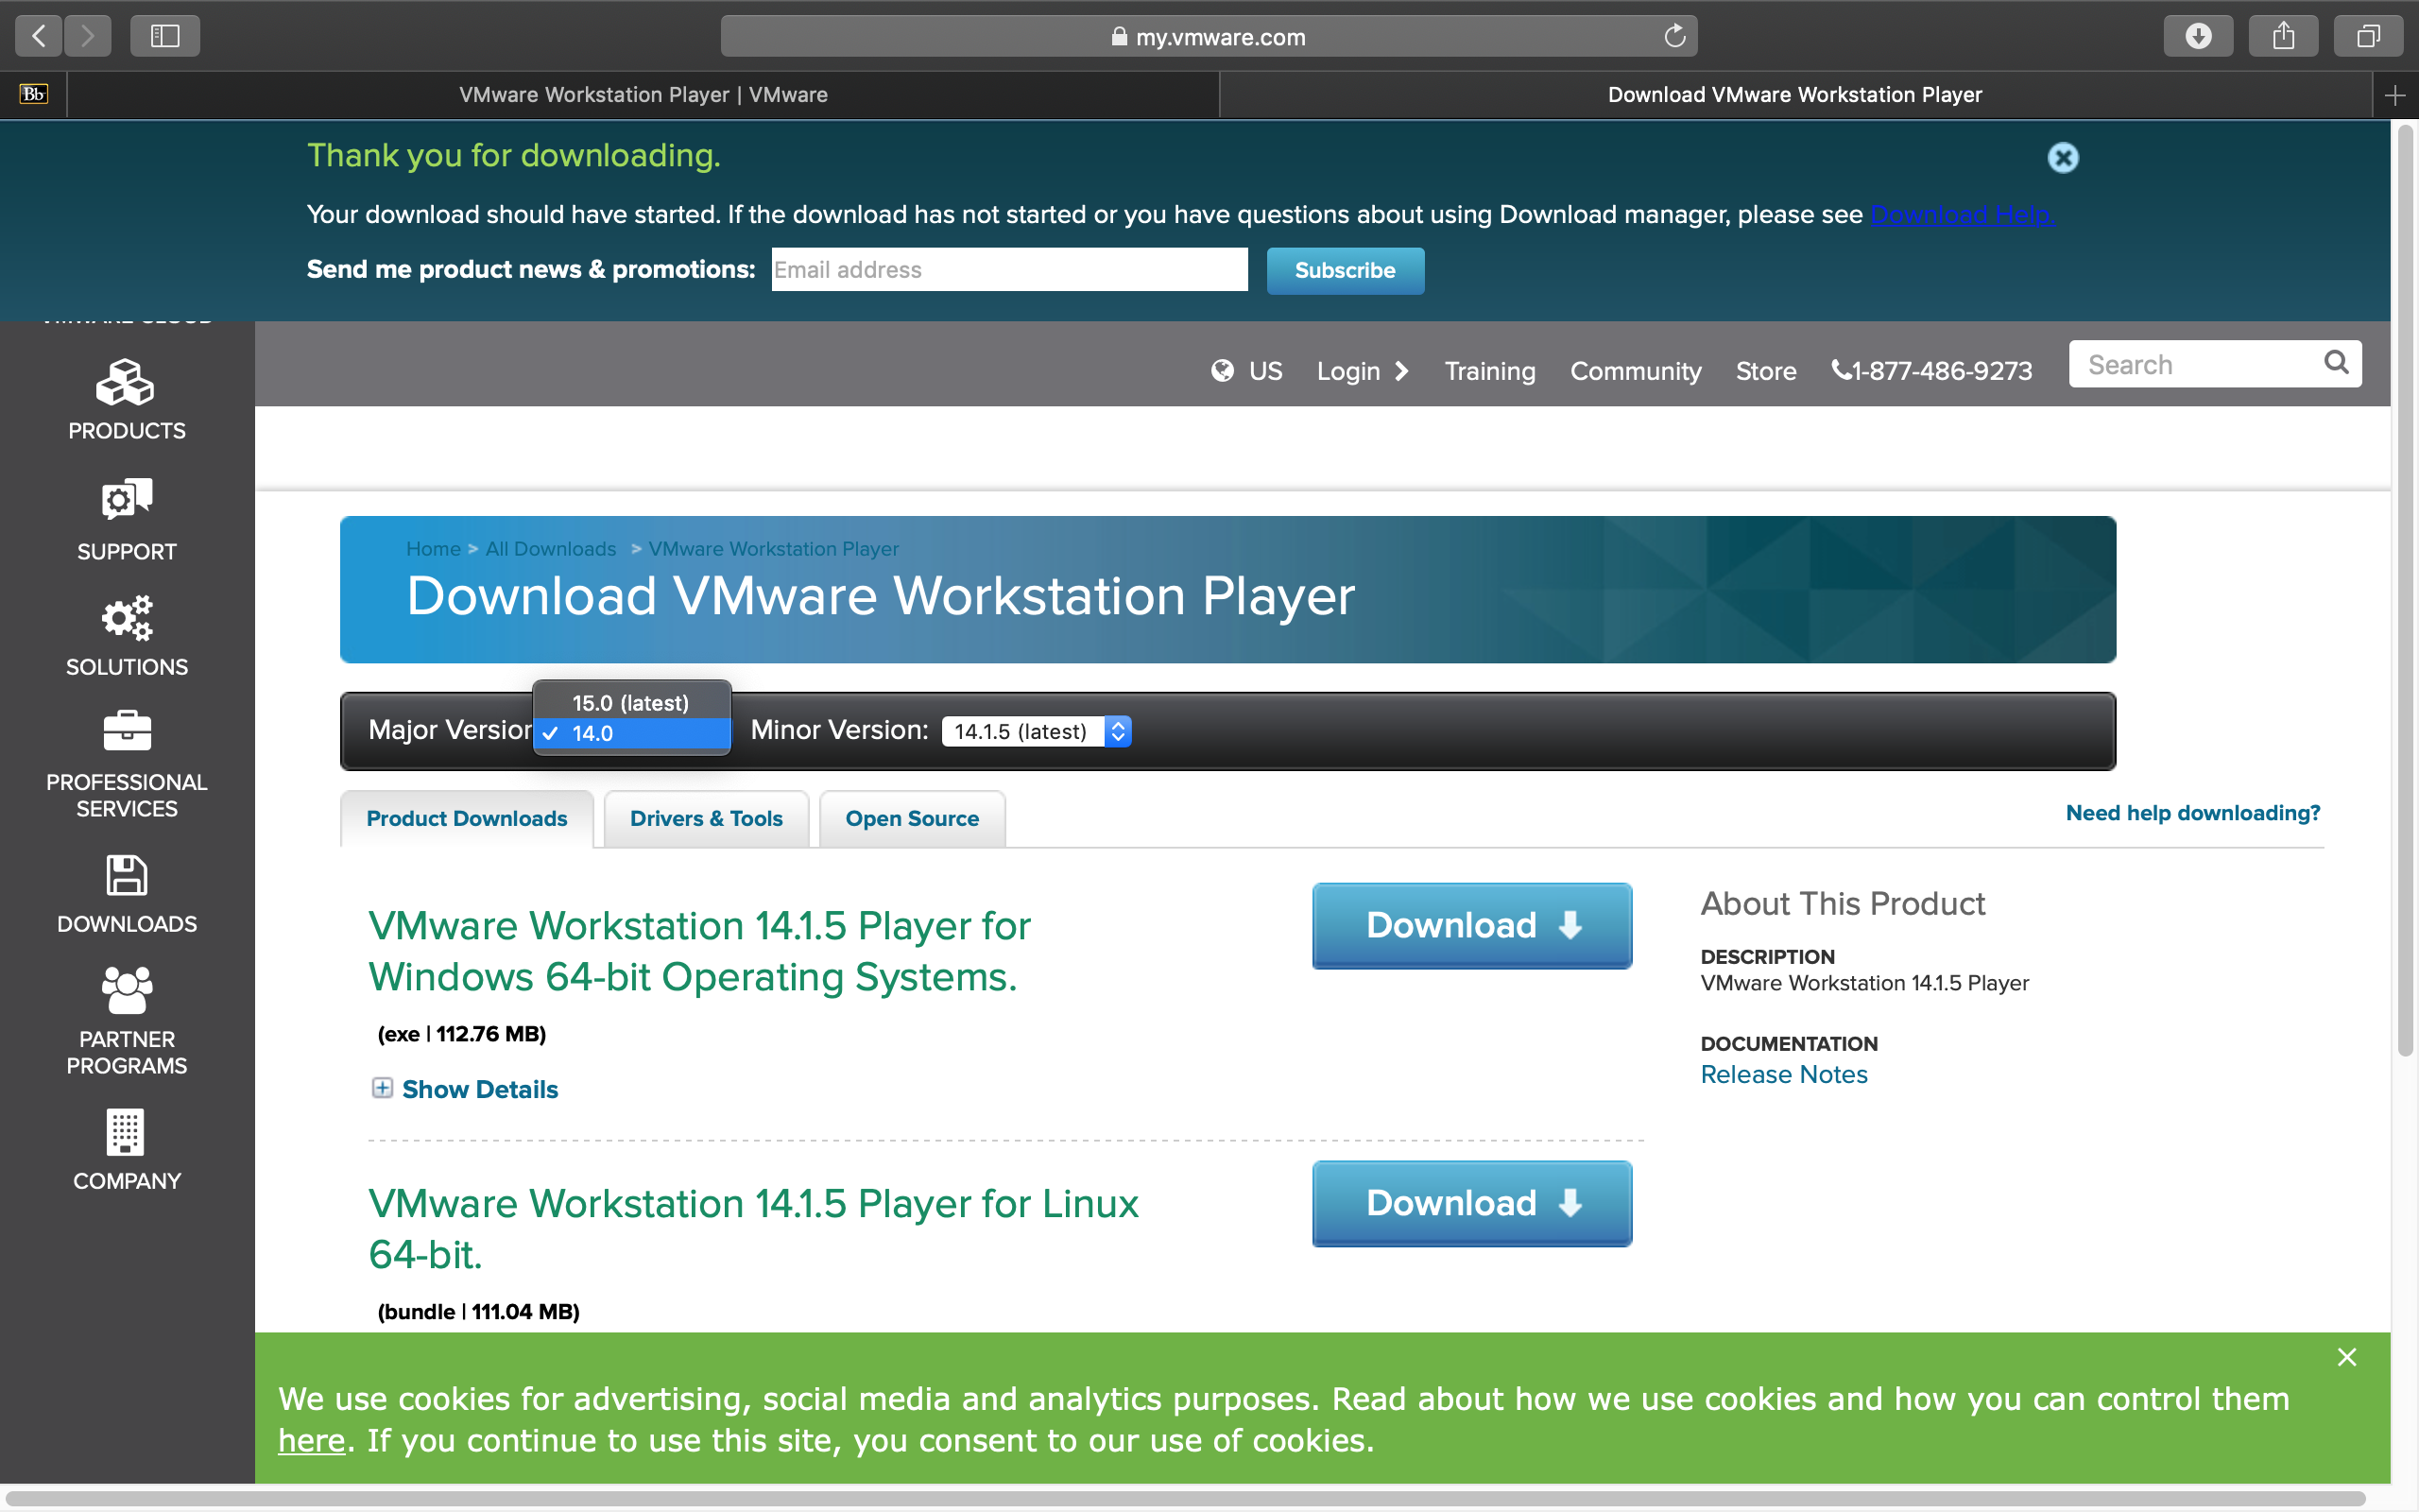

Step 2: Double click on the VMware .exe file that you downloaded in Step-1. You should see a prompt that says, “Do you want this application to make changes to your device”. Select “Yes”, Now you should see a setup wizard for the VMware Player as shown below. Click “Next”.

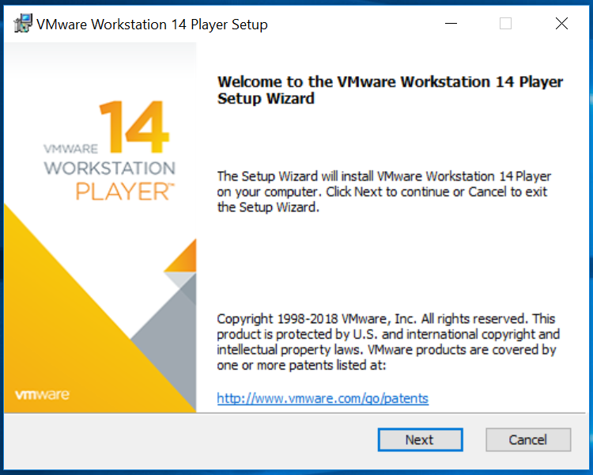

Step-3: In this prompt you should see an End-User license agreement. Select the checkbox that says, “I accept the terms of the license agreement” and click “Next” as shown in the screenshot below.

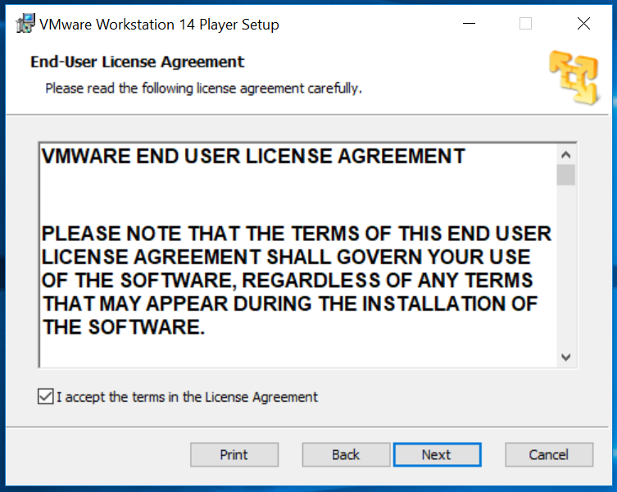

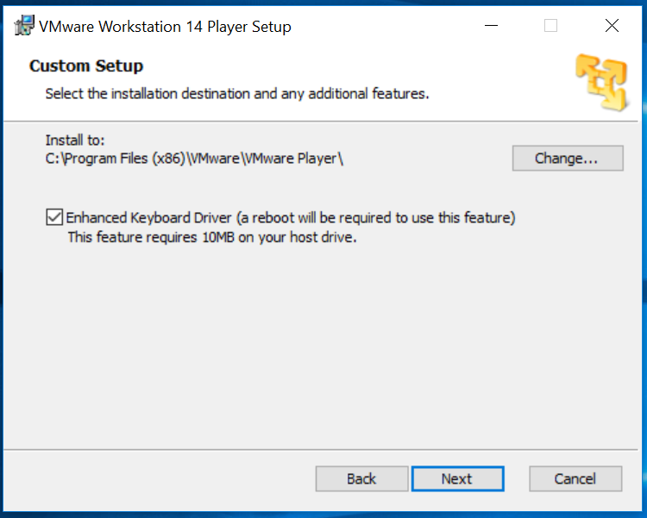Step-4: Now you will see a prompt that is titled “Custom Setup”. Select the checkbox that says, “Enhanced Keyboard Driver” and click “Next”. A screenshot of the prompt is shown below.

Step-5: Now you should see a prompt titled “User Experience Settings”. The boxes should be checked by default but if they are not, check the boxes shown in the screenshot below and “Next”.

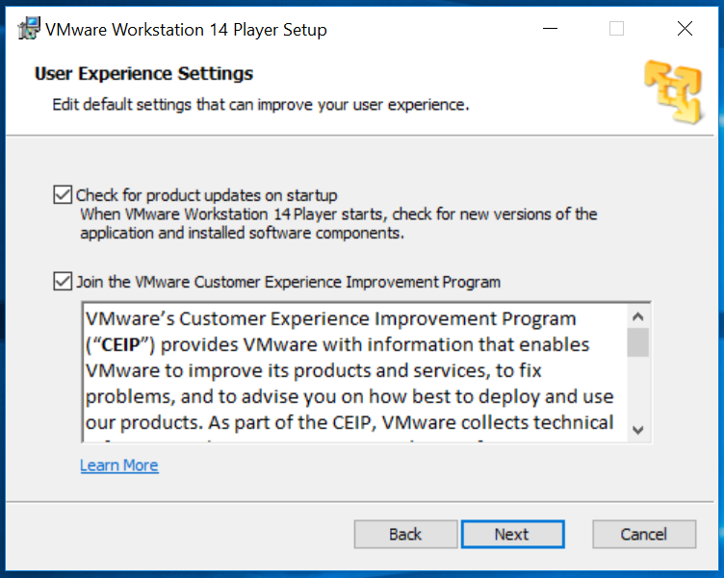

Step-6: This prompt should be titled “Shortcuts”. Select the “Desktop” and “Start Menu Program Folder” checkboxes as shown below and click “Next”.

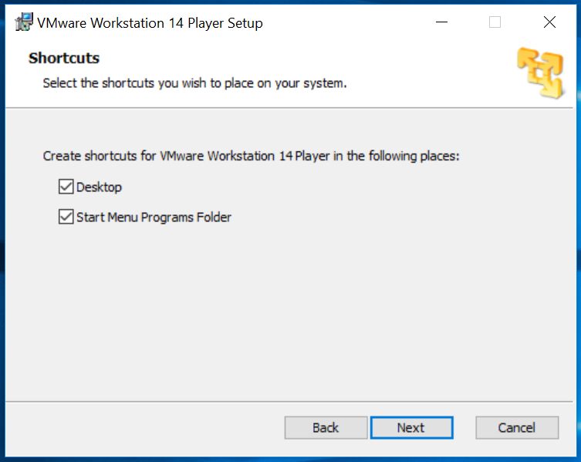

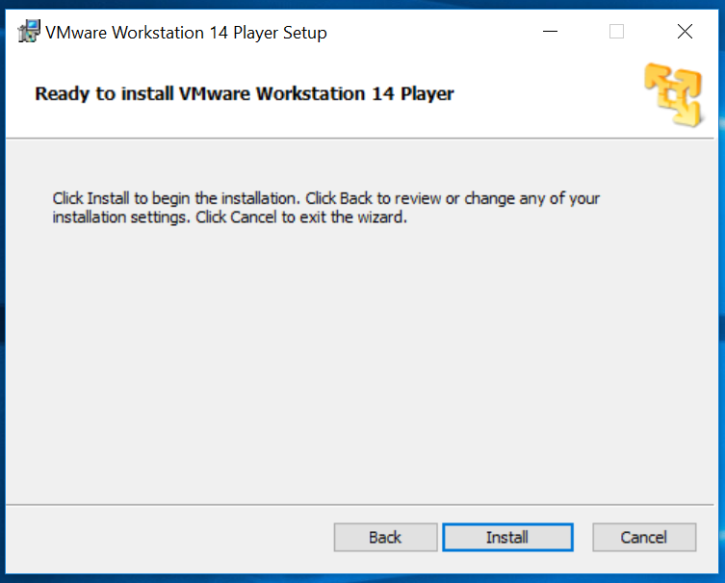Step-7: In this prompt, click “Install”. After clicking install you should see a progress bar showing how far your installation has come along. Screenshots of both these windows are shown below.

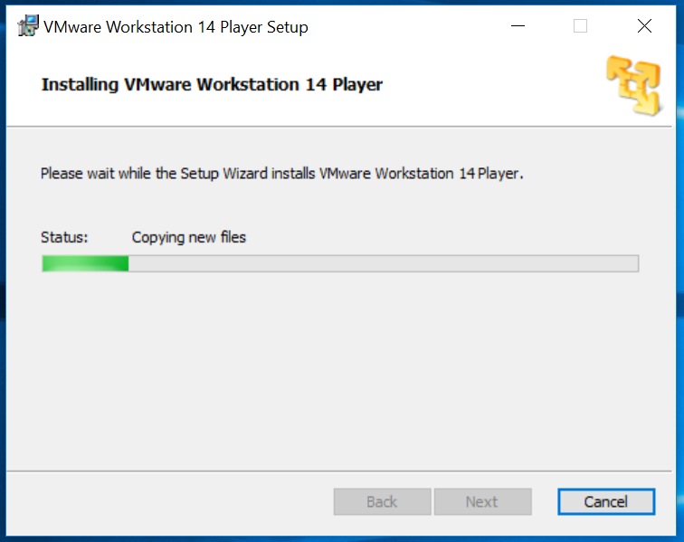

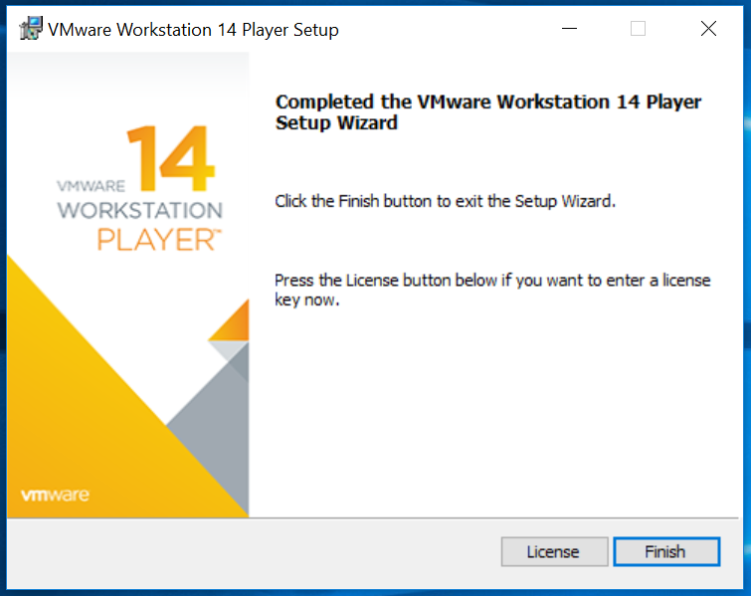Step-8: In this window, click “Finish”. After you click finish, you will be prompted to restart your system, select “Yes”. Screenshots of both these windows are shown below.

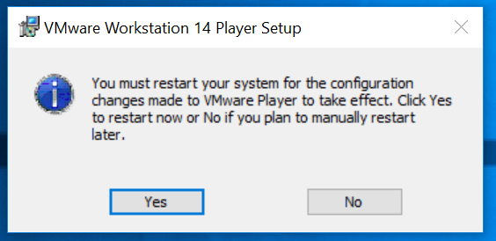

Step-9: Once your system has restarted and you have logged in, open up the VMware workstation 14 Player application that should be on your desktop. You should see a prompt asking you to provide a key or use the application for free, select “Use VMware Workstation 14 Player for free for non-commercial use” and click “Continue” as shown below.

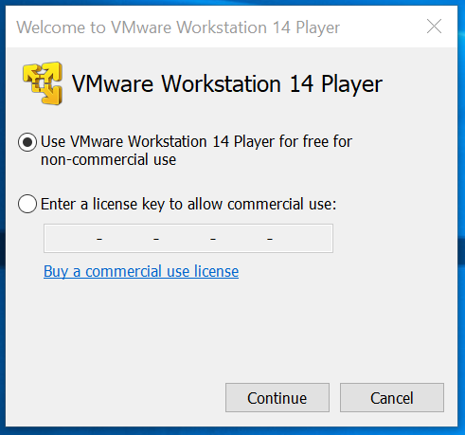

Step-10: This prompt should be titled “Welcome to VMware Workstation Player 14 Player”. Click “Finish” as shown in the screenshot below.

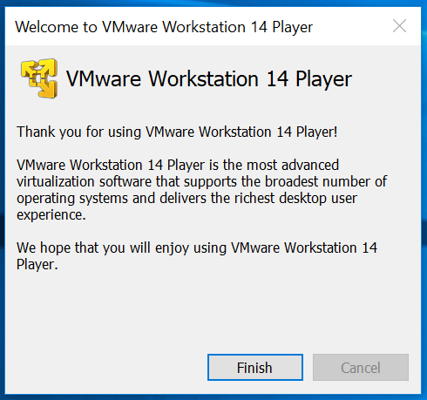

Q. The VMware Workstation 14 Player should have started. Paste a screenshot of the application homepage screen.

Part 2: Cloudera VM: This section covers setup of the Cloudera VM.

Step-11: Navigate to the link provided below, it is a box account. If you are signed in to eLearning or any other UT Dallas website, you should be automatically re-directed to the to the page shown below. If not, login with your netid and password. Click “Download”.

NOTE:

1. Use Google Chrome to download the Cloudera VM.

CLOUDERA VM LINK: <https://utdallas.box.com/s/ytxfjispyg47labspu1tdzvz9aoedn14>

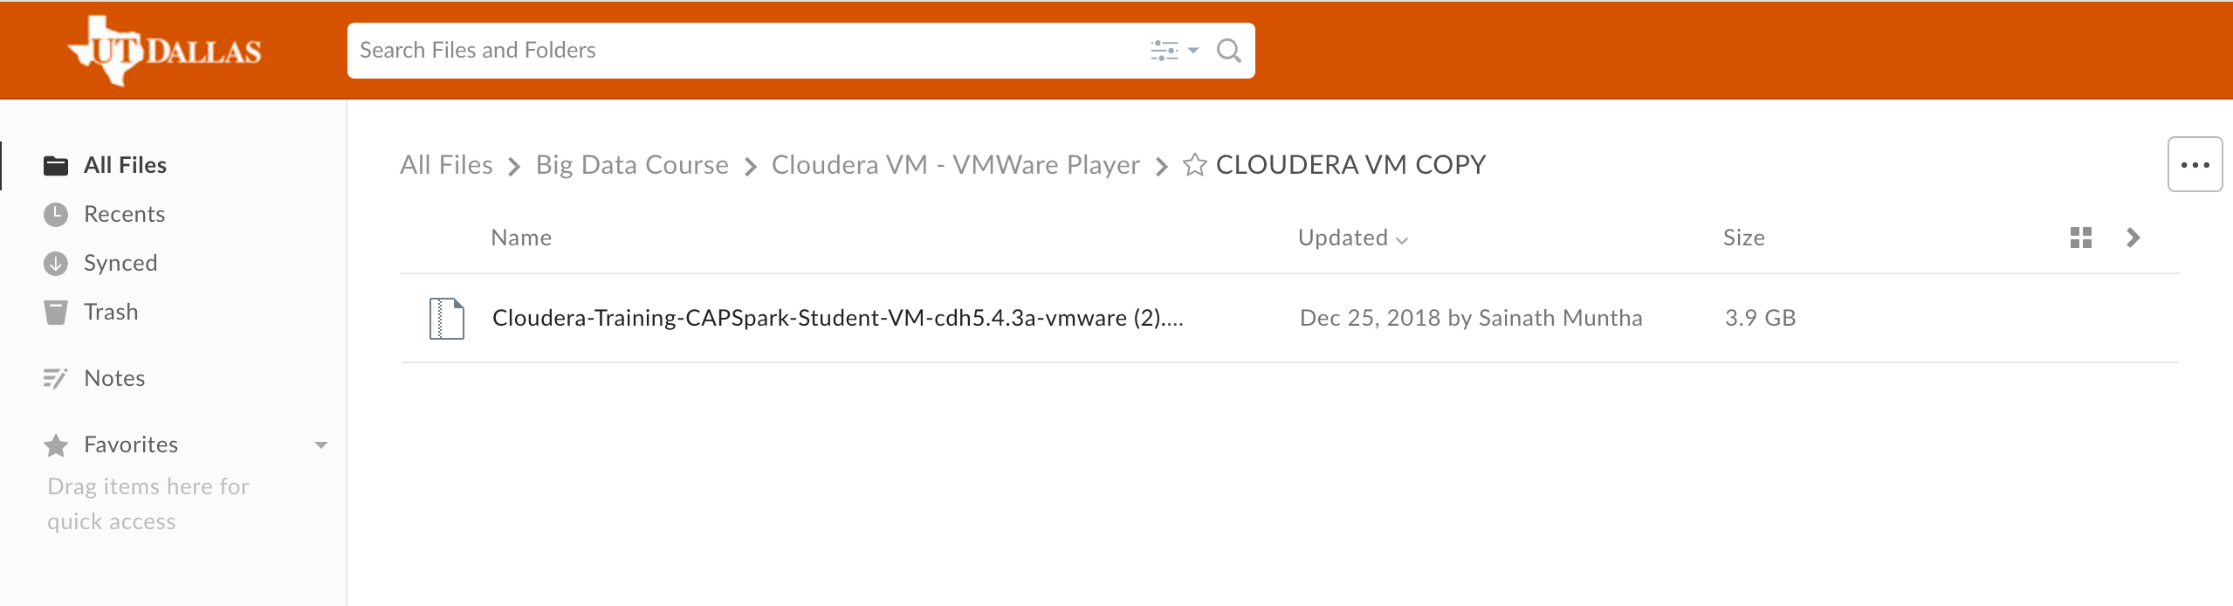

Step-12: Navigate to the location to which you downloaded the file in Step-11 and unzip the file to your desktop, as shown in the screenshot below.

**NOTE: Take a look at the question below before clicking “Extract”.**

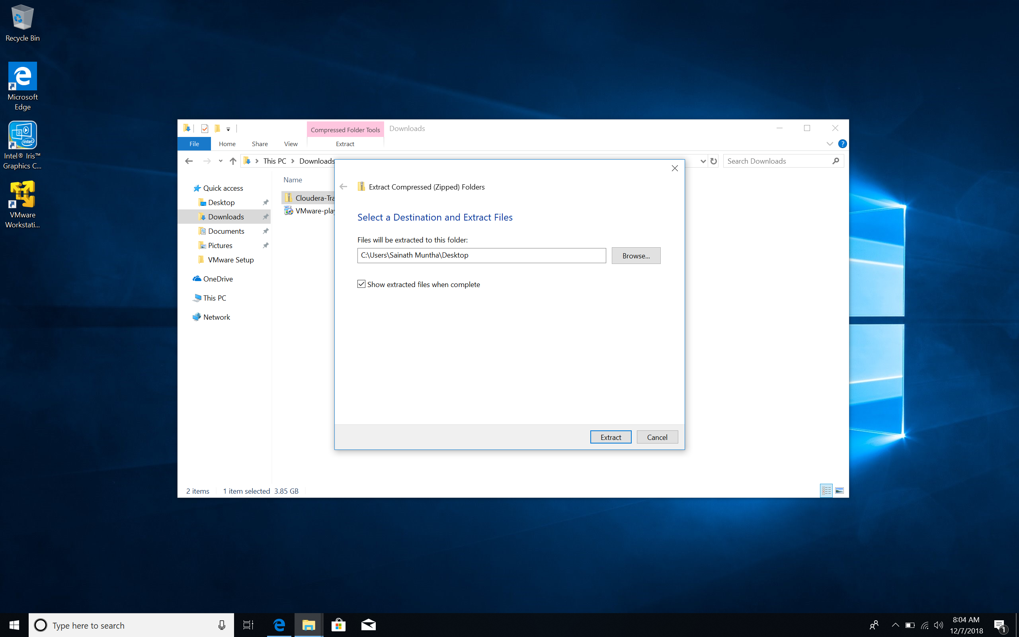

Q. Provide a screenshot before you extract the file to your Desktop. In this screenshot I should be able to see the destination to which you are extracting the file. The screenshot should be identical to the one that I have provided above.

Step-13: After the file has been extracted, open VMware Workstation 14 Player that we setup in Part-1 and click “Open a Virtual Machine” as shown in the screenshot below.

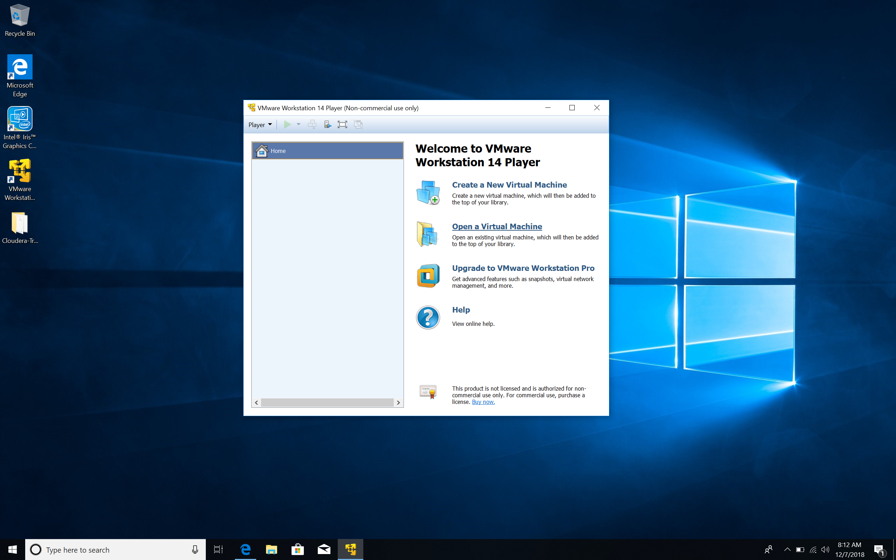

Step-14: Navigate to the location to which you unzipped the file that you downloaded in Step-12, select the “cloudera-training-capspark-student-rev_chd5.4.3a” and click “Open”, as shown in the screenshot below.

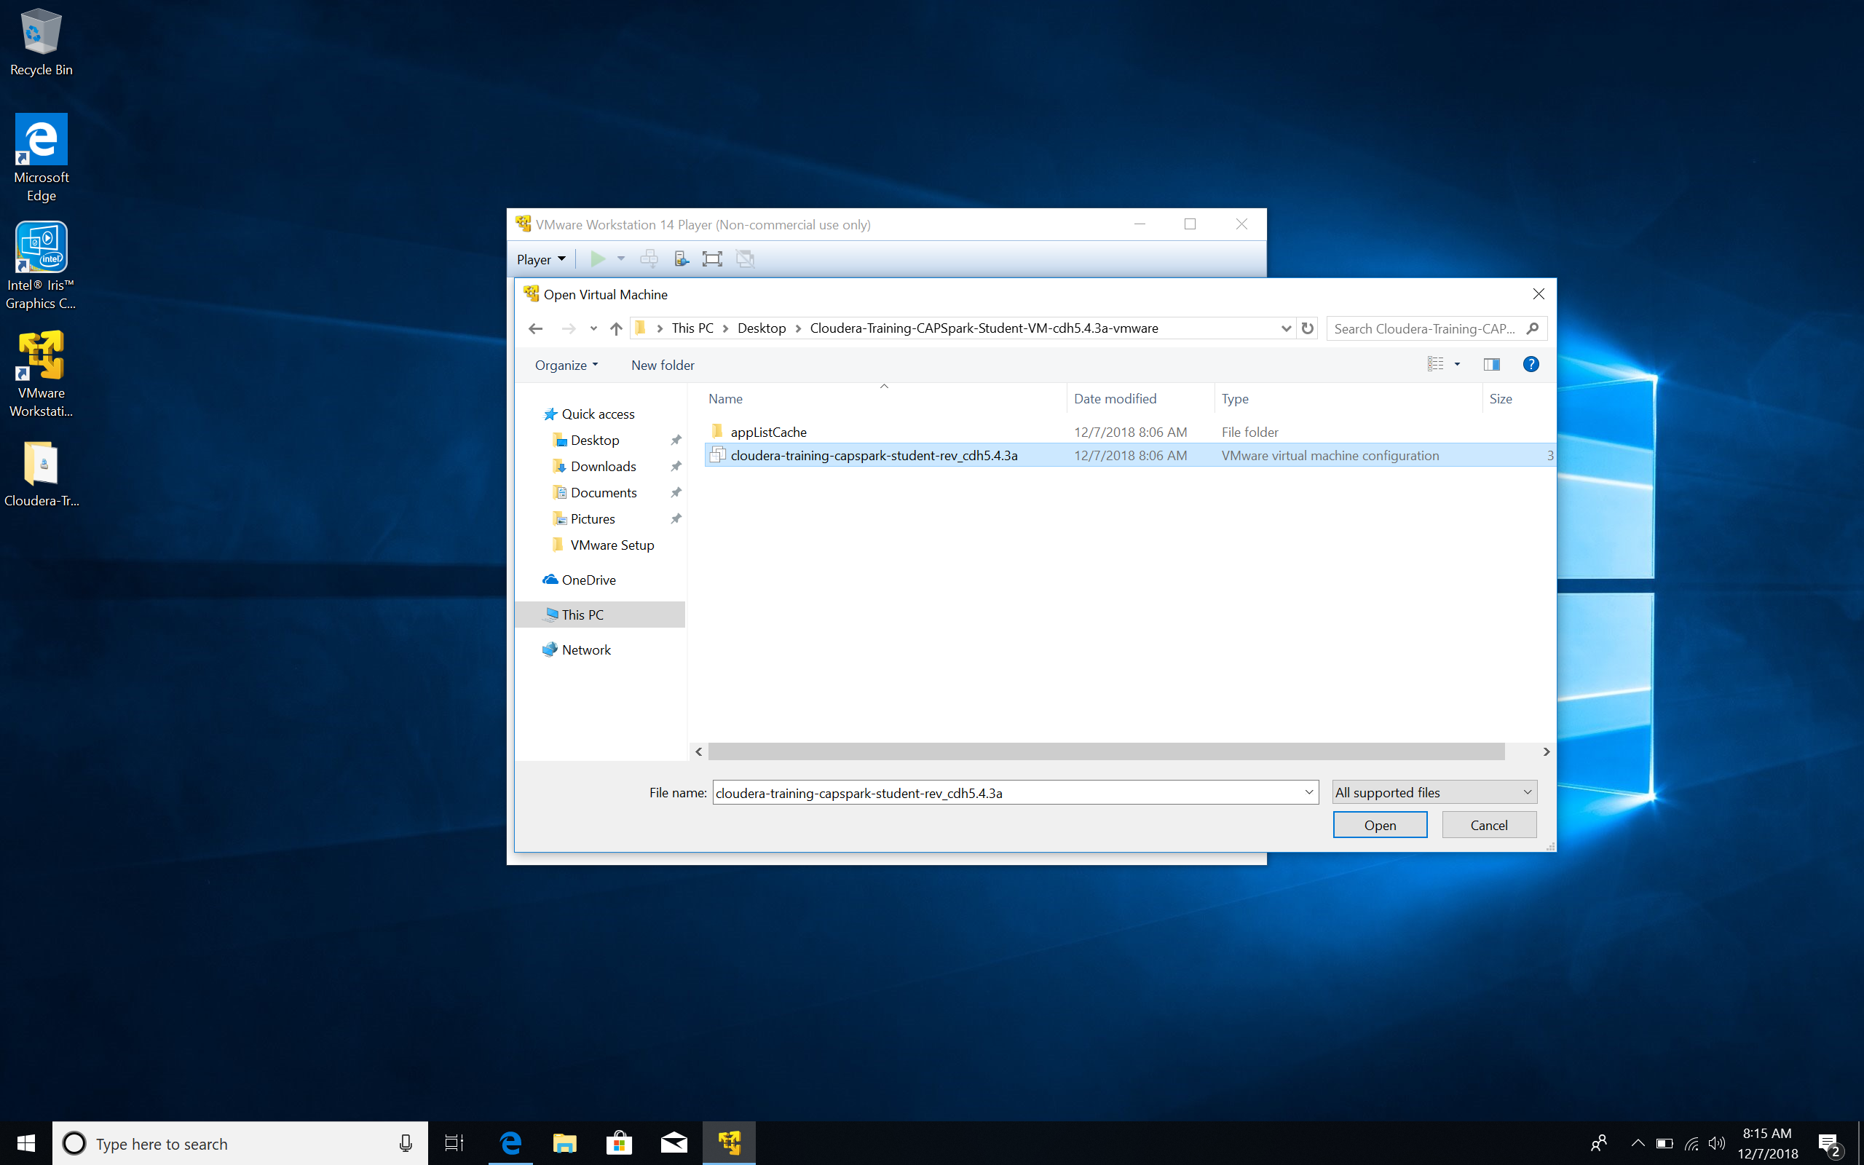

Q. Provide a screenshot of the VMware Workstation 14 Player with the Cloudera Quick Start VM added under the Home button.

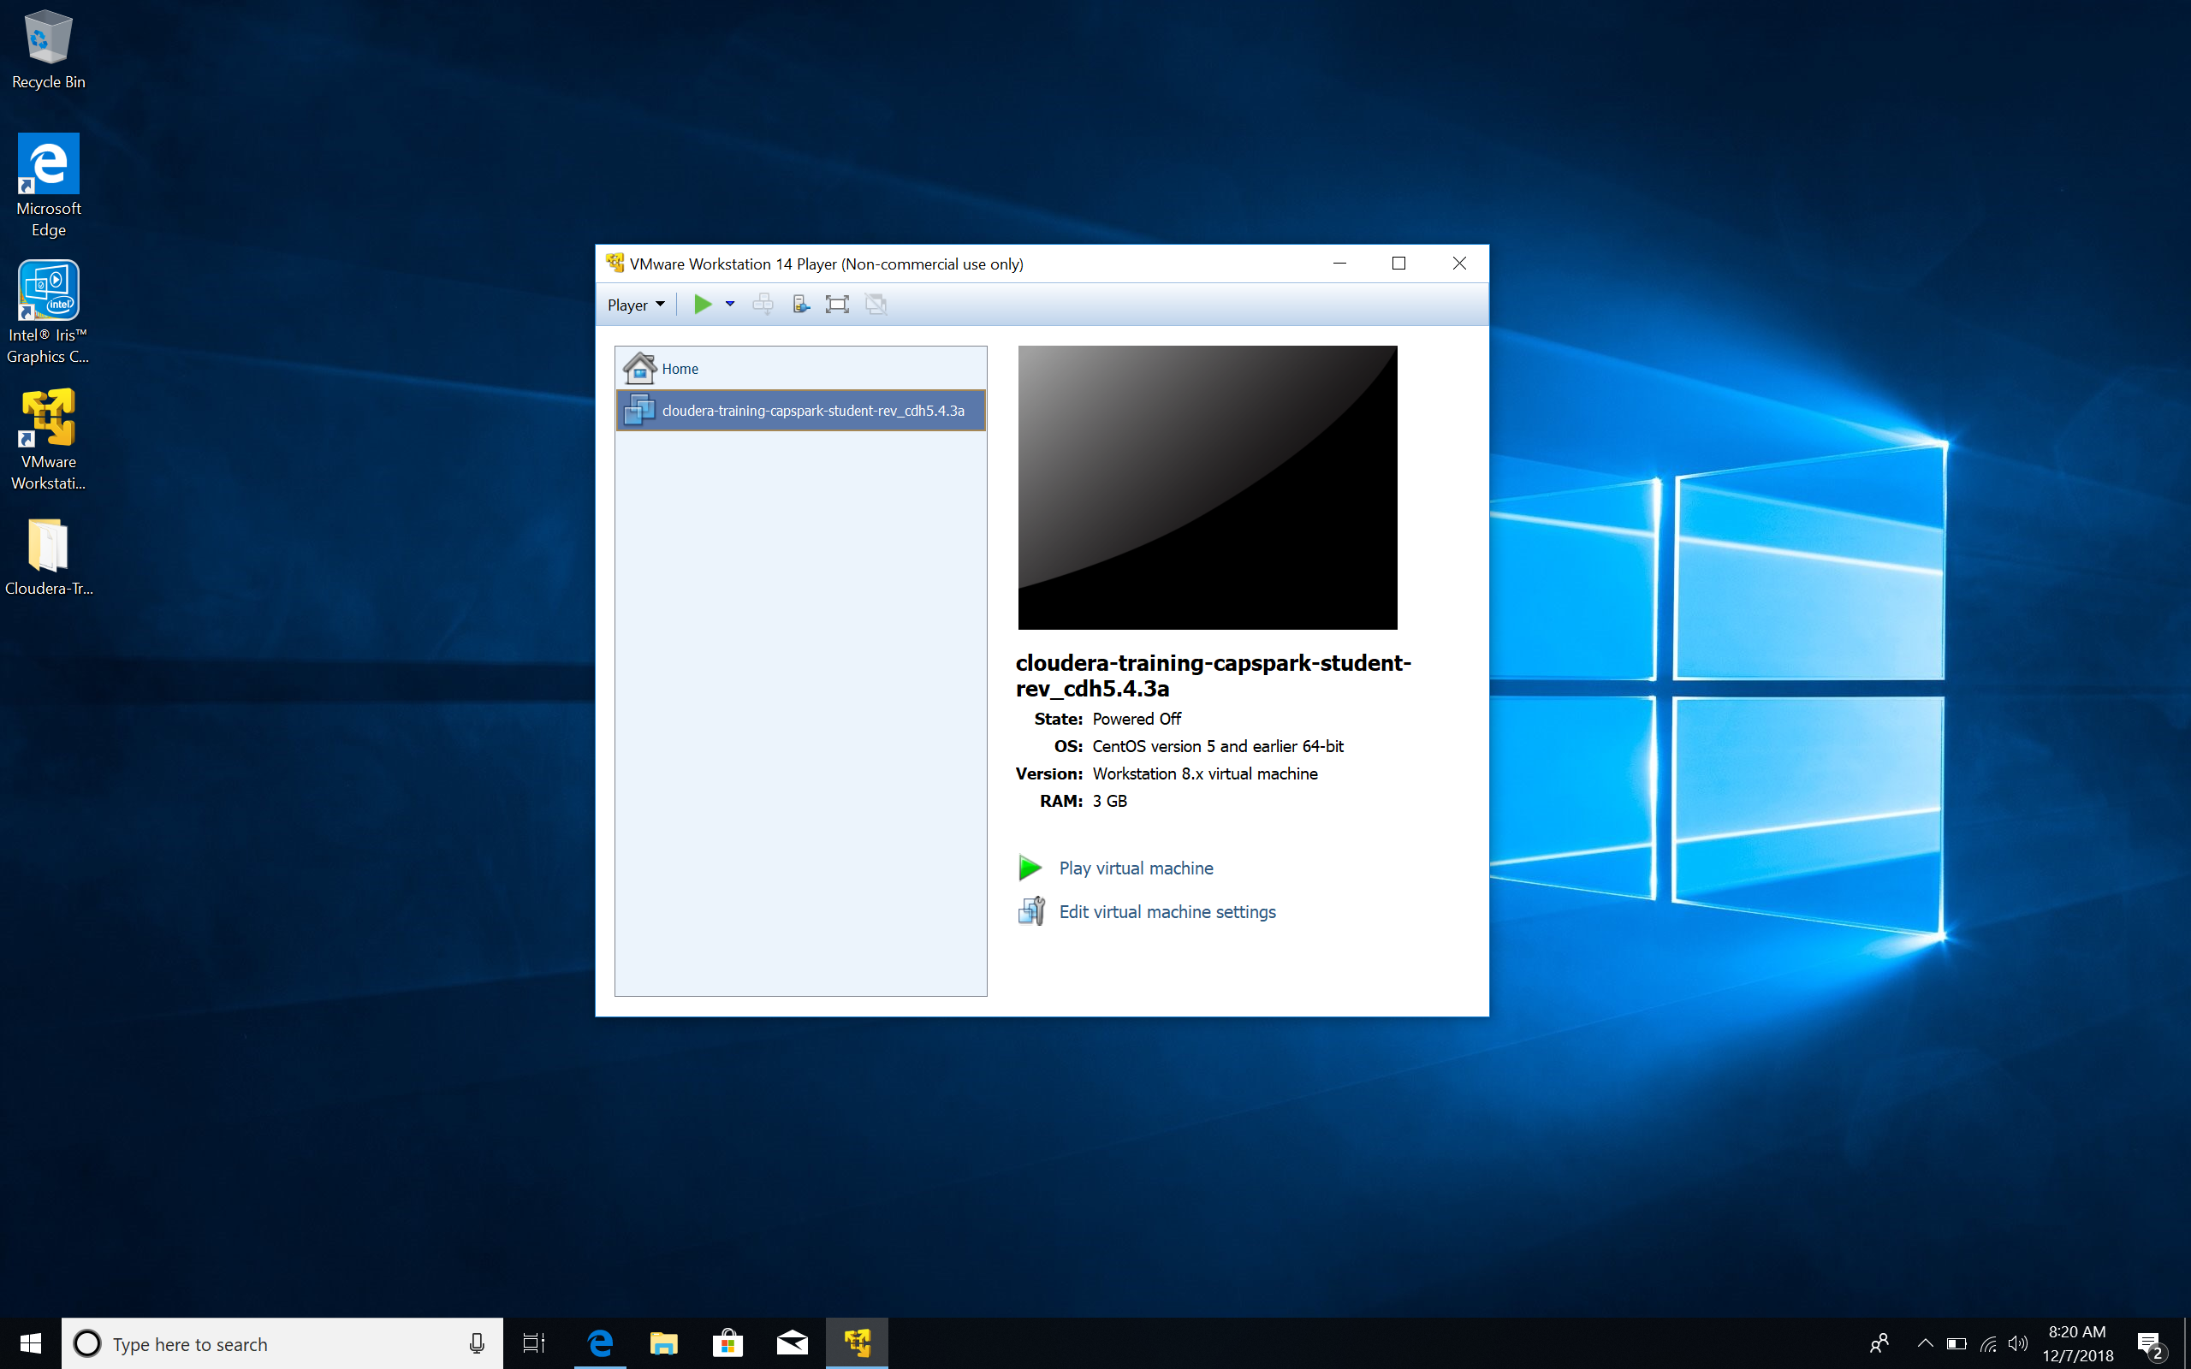Step-15: In the VMware Workstation 14 Player select the VM you added in Step-14 and click on “Play virtual machine” as shown in the screenshot below.

**NOTE: If the VM starts and then shuts down automatically, you have to modify a setting in the BIOS. Boot up your PC in safe mode (so you can access your BIOS settings) enable a Virtualization setting (it is called by a different name on different computers) and restart the PC. The VM should start now.**

**For specific steps on how to access the BIOS of your PC, use Google.**

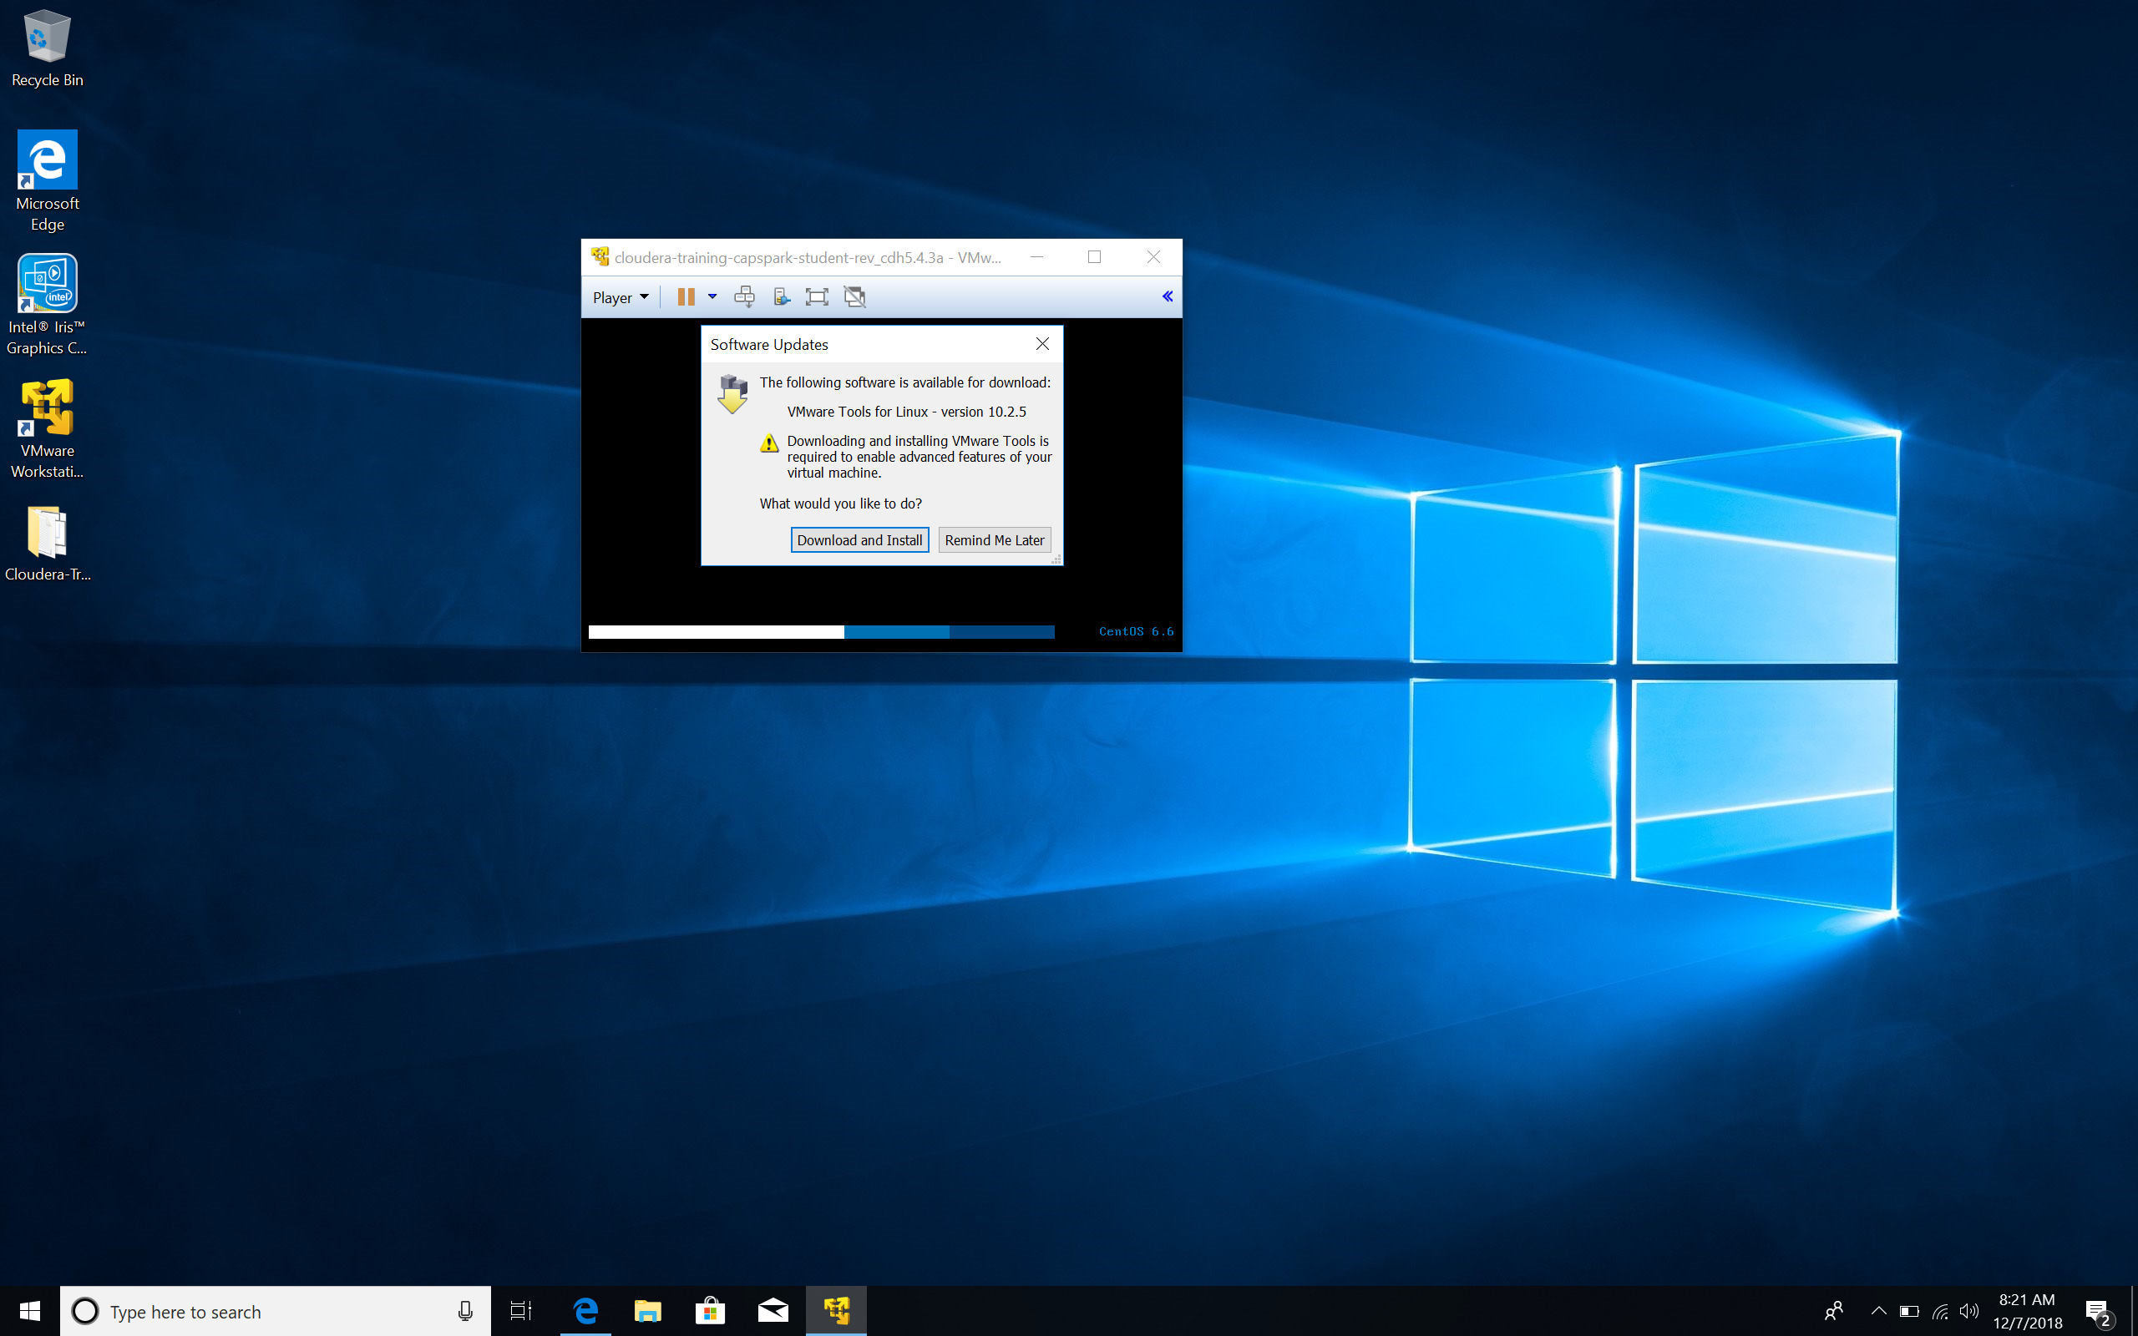Step-16: You will see a prompt that is titled “Software Updates” click “Download and Install” as shown in the screenshot provided below.

Step-17: Now you will see a prompt that says, “Do you want this app to make changes to your device?”, click “Yes”.

Q. The VM will have booted up by now, maximize the VM screen and take a screenshot of the VM desktop and paste it below.

Part 3: Navigation: This section covers basic navigation in the Cloudera VM.

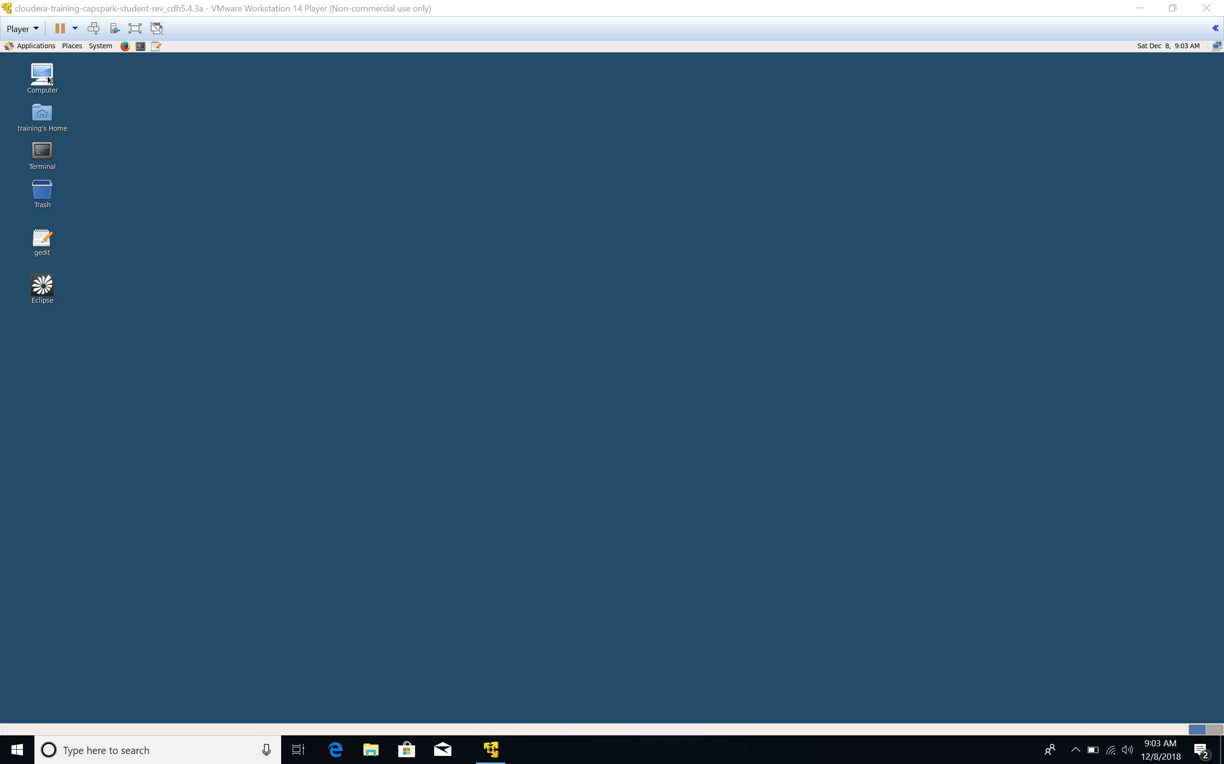Step-18: Observe the computer icon highlighted in the screenshot below. This computer icon is analogous to “finder” in Mac or “explorer” in Windows. You may use it to browse files that are located on the *host system*.

Q. Open the “Computer” application, click on the “training” directory, take a screenshot and paste it below.

Step-19: Open the “gedit” application highlighted in the screenshot below. This application is a simple text editor. It may come in use for other exercises throughout the semester.

Q. Open the “gedit” application, in the text editor type “I Love Hadoop” and save it on the desktop with the filename “FirstName_LastName”. Open the file you just created, take a screenshot and paste it below.

NOTE:

1. Replace FirstName and LastName with your first name and last name, DO NOT copy as is

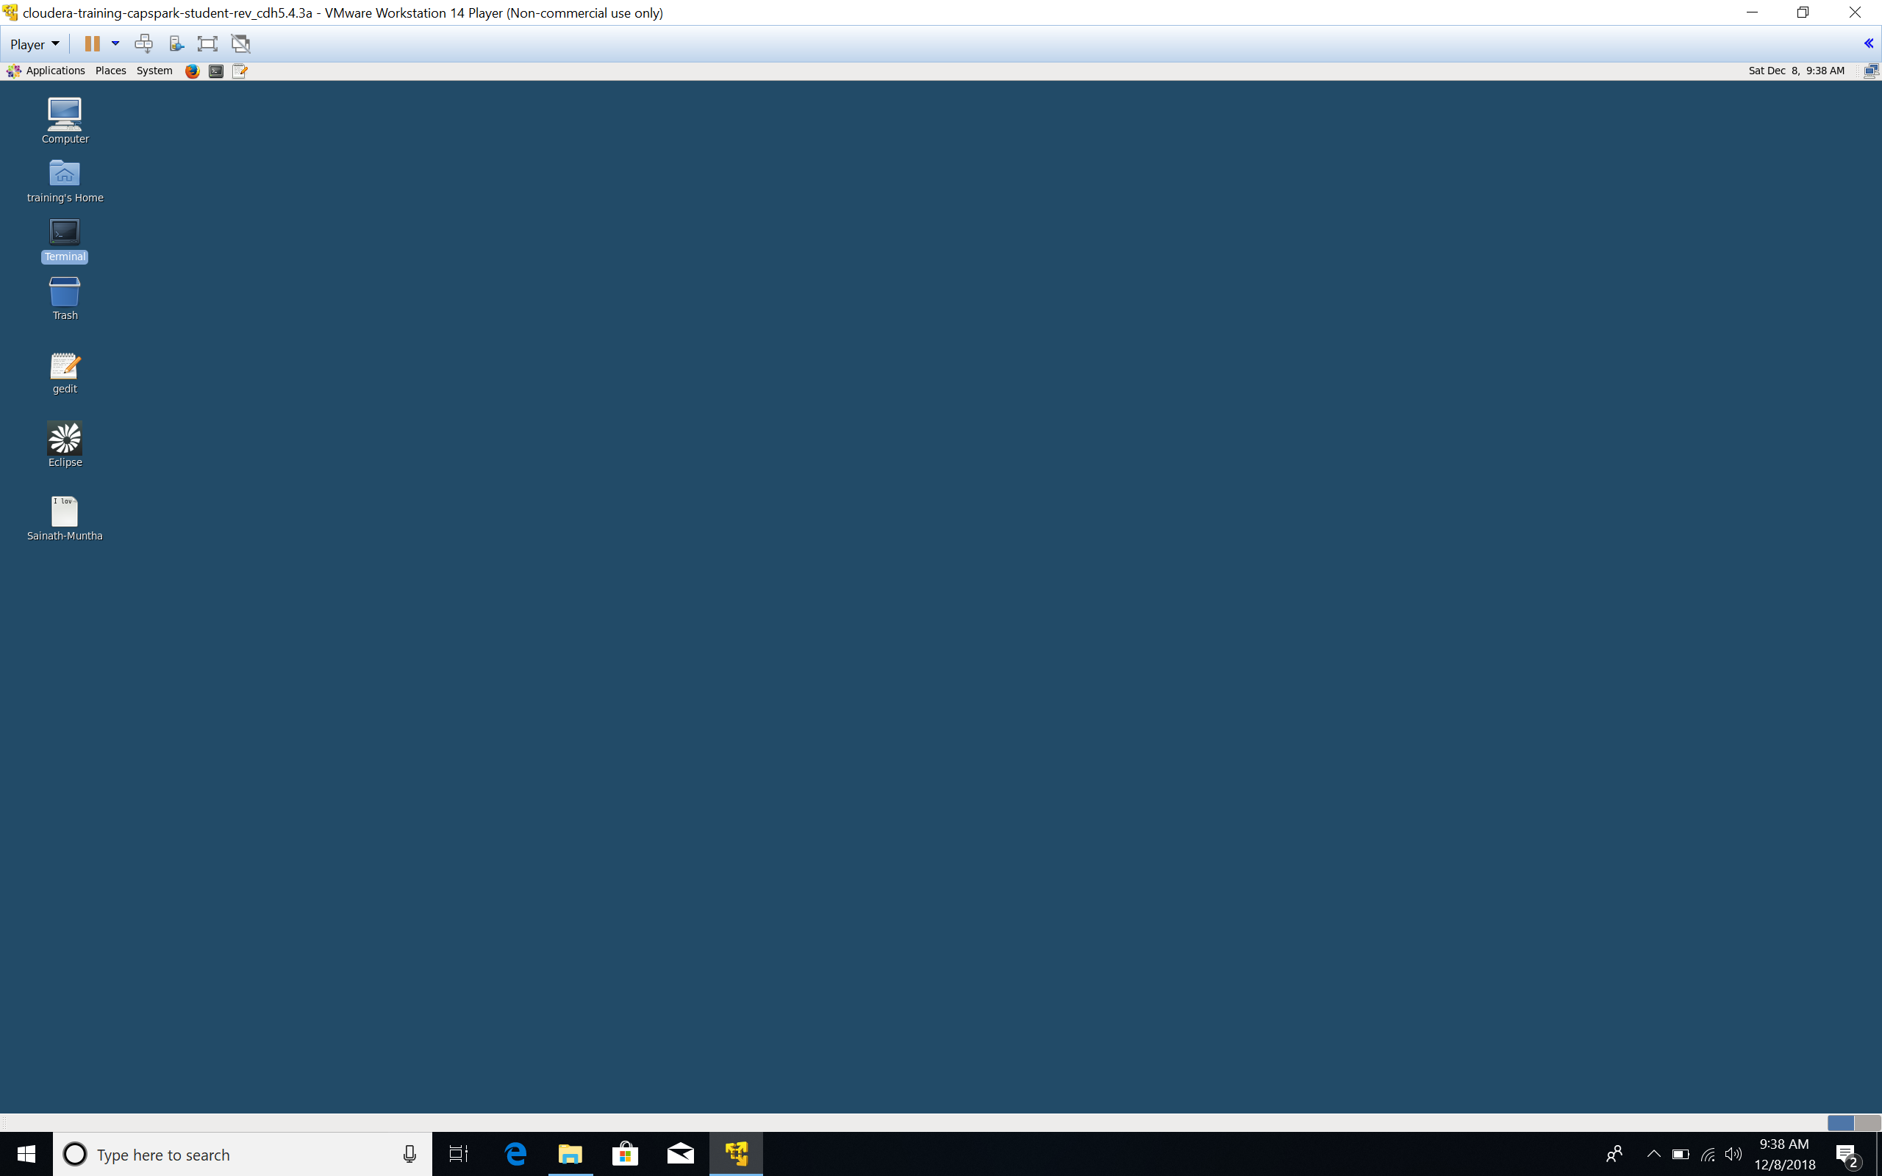Step-20: The icon highlighted in the screenshot below is called a terminal. The terminal is an application that provides text-based access to the operating system. You will use the terminal for most parts of the labs that involve the Cloudera VM. To increase the size of the font in the terminal, use the command “Control” + “shift” + “+”.

Q. Open the “terminal” application, type the command “ls” and hit enter. Take a screenshot of this screen and paste it below. Do you see any similarity to the screenshot you took in Step-18?

NOTE:

1. Increase the size of the font so the text is clearly visible in the screenshot

Step-21: In the “terminal” application execute the following command:



This script enables services and sets up the data that is required for the course. Your terminal should be identical to the screenshot below.

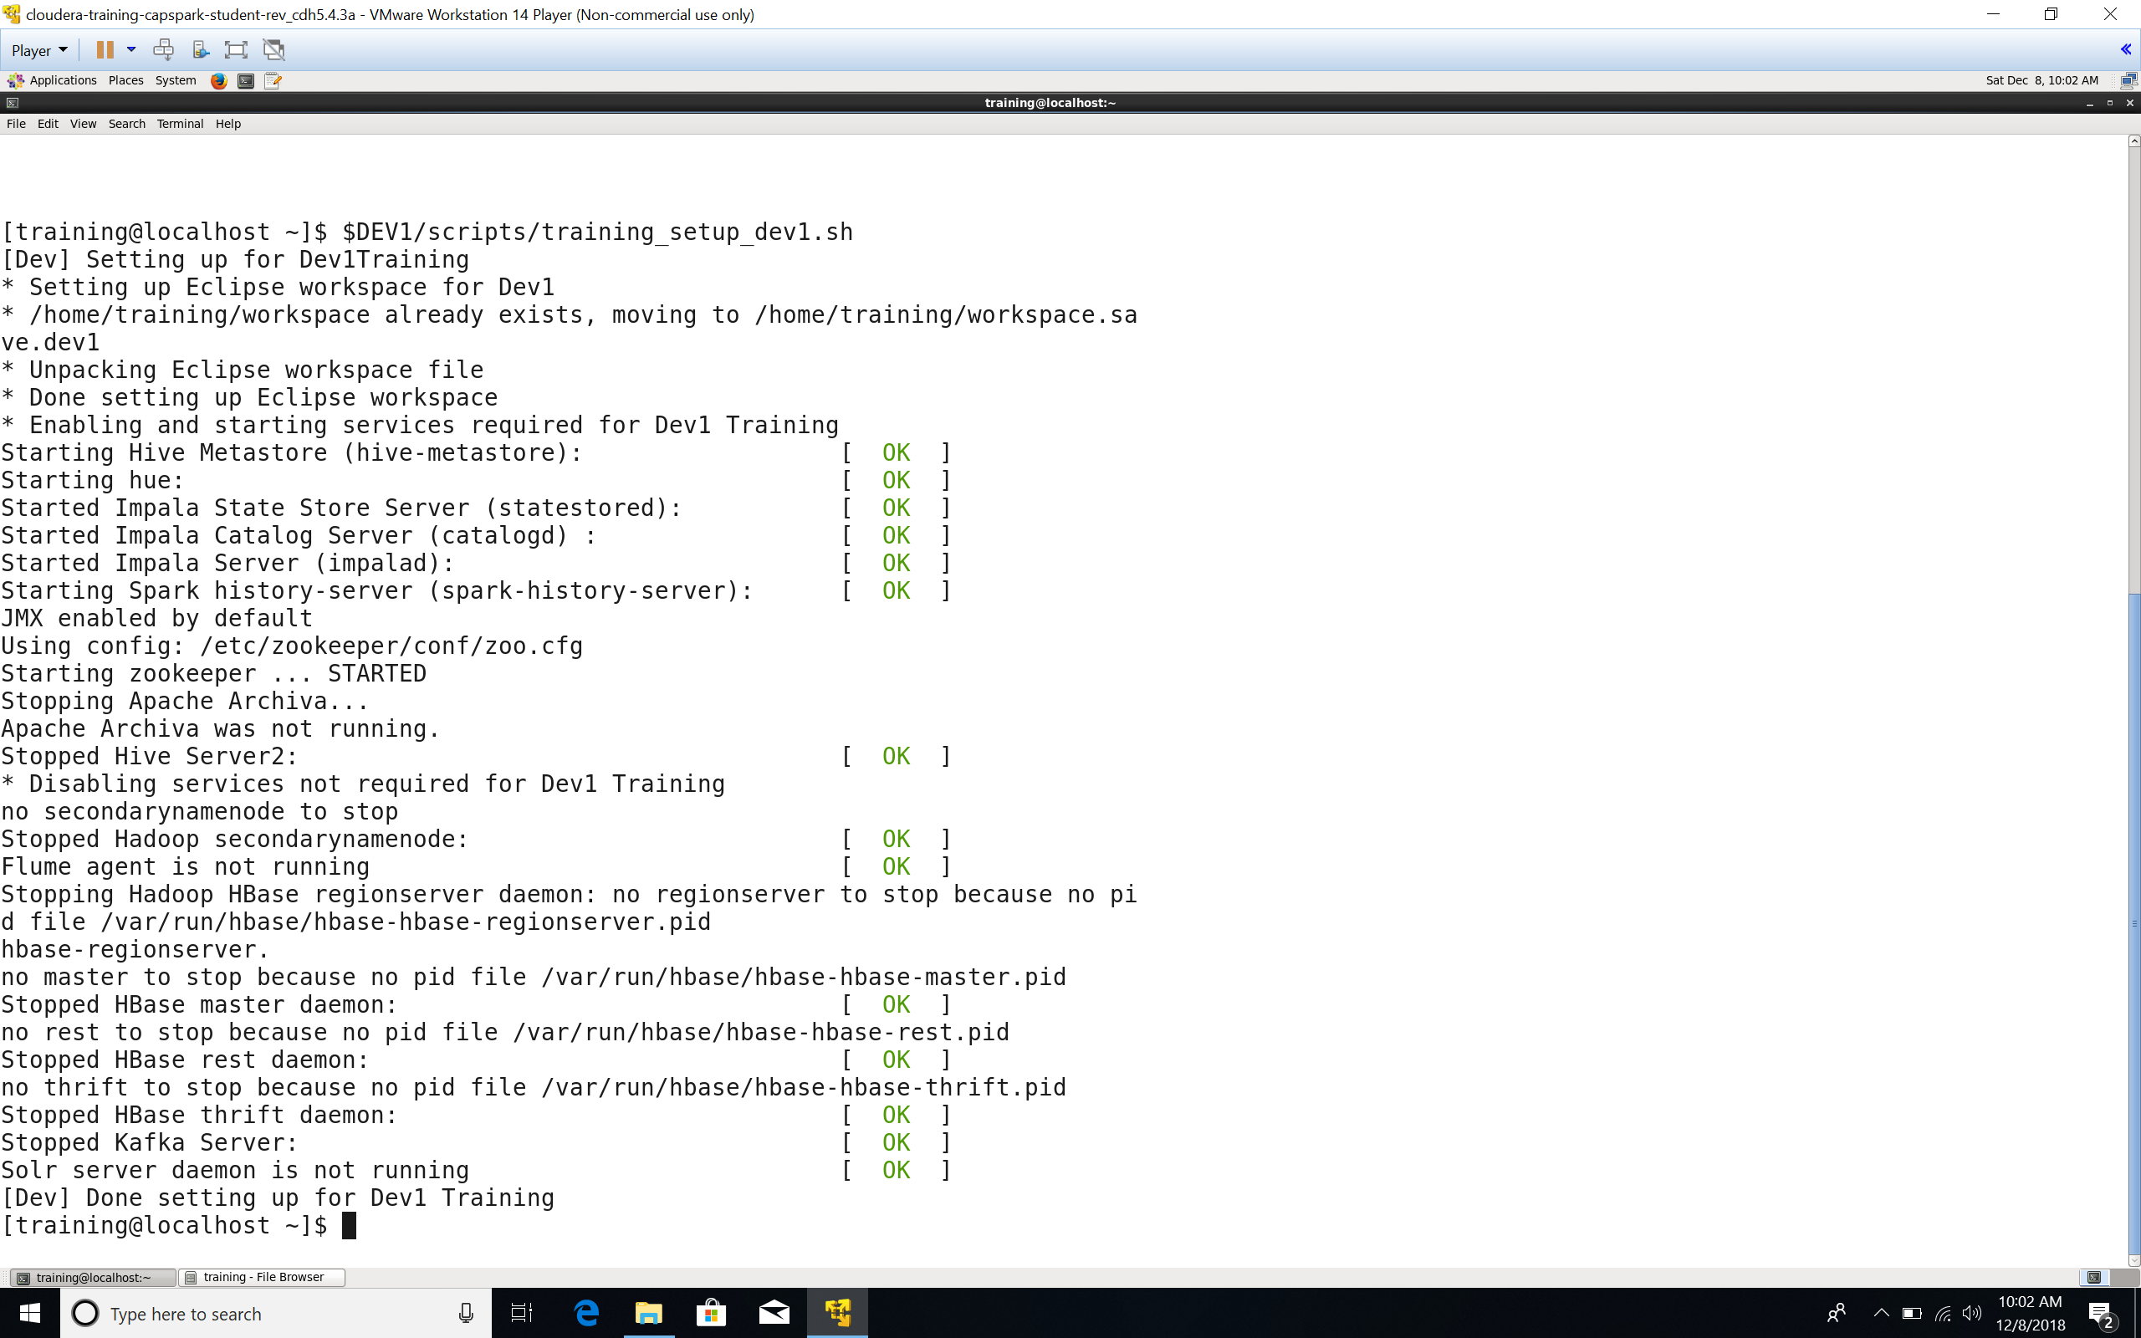

Step-22: In the “terminal” application, execute the following command:



Explanation: This statement will create a top-level directory in HDFS that will be used throughout the semester.

NOTE:

1. Replace FirstName and LastName with your first name and last name, DO NOT copy as is.

Step-23: Open the “Mozilla Firefox” browser that is located at the top of the screen. Click on the bookmark called “HUE” as shown in the screenshot below. HUE stand for Hadoop User Interface. You will now see a page that is titled “Create HUE Account”. Use the following credentials and click “Create Account”.

ID: training

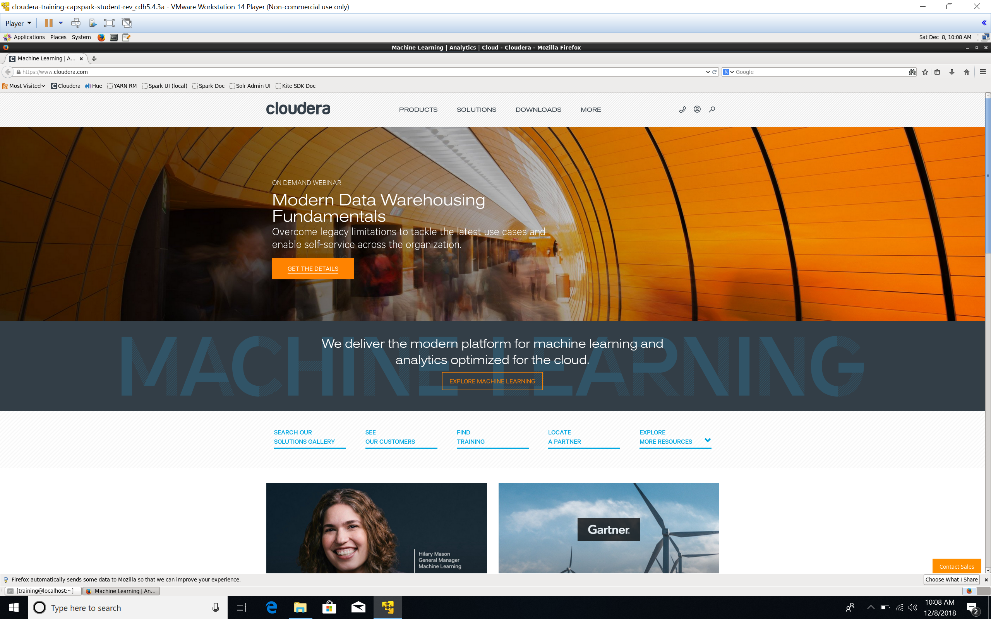Password: training

Q. Take a screenshot of the HUE splash screen and paste it below.

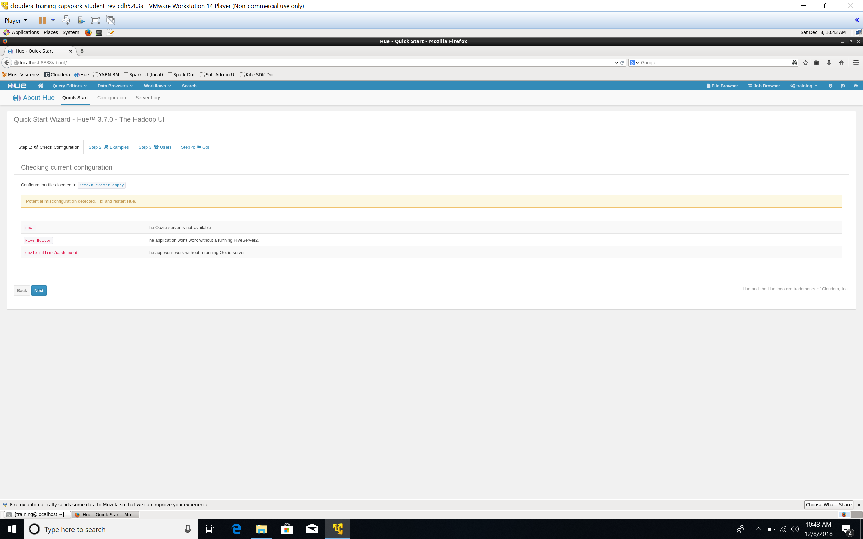Step-24: In the HUE UI, click on the file browse icon as shown in the screenshot below. Now click on “/” or root directory in the path as shown in the second screenshot below.

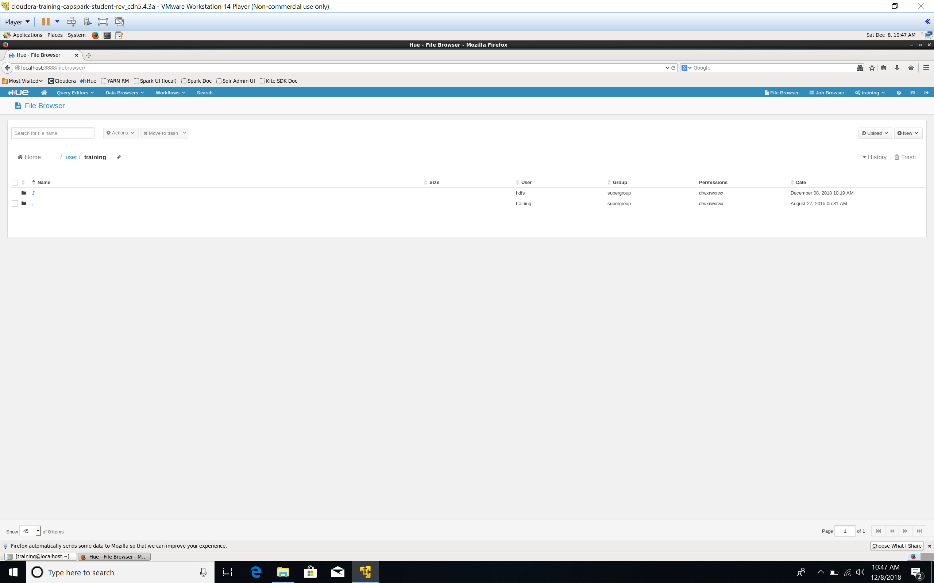

Q. Take a screenshot of this page in HUE and paste it below. You should see the directory that you created in Step-22.

Step-25: Execute the following commands in the “terminal” application.



Explanation: With these two commands we are essentially copying a directory called kb from the local file system into HDFS.

NOTE:

1. Replace FirstName and LastName with your first name and last name, DO NOT copy as is.

Q. Switch back to HUE, click on the loudacre_FirstName_LastName directory that you created in Step-22. Take a screenshot and paste it below. What do you see in this directory?

Step-26: To shut down the VM gracefully, close all the applications and then go to ‘System” located at the top of the screen and click on “shutdown” as shown in the screen shot below.

NOTE:

1. Follow this procedure each time. Shutting the VM in another fashion may corrupt the VM file, which means you would have to start from scratch. This will be extremely tedious as each exercise builds upon the previous one.

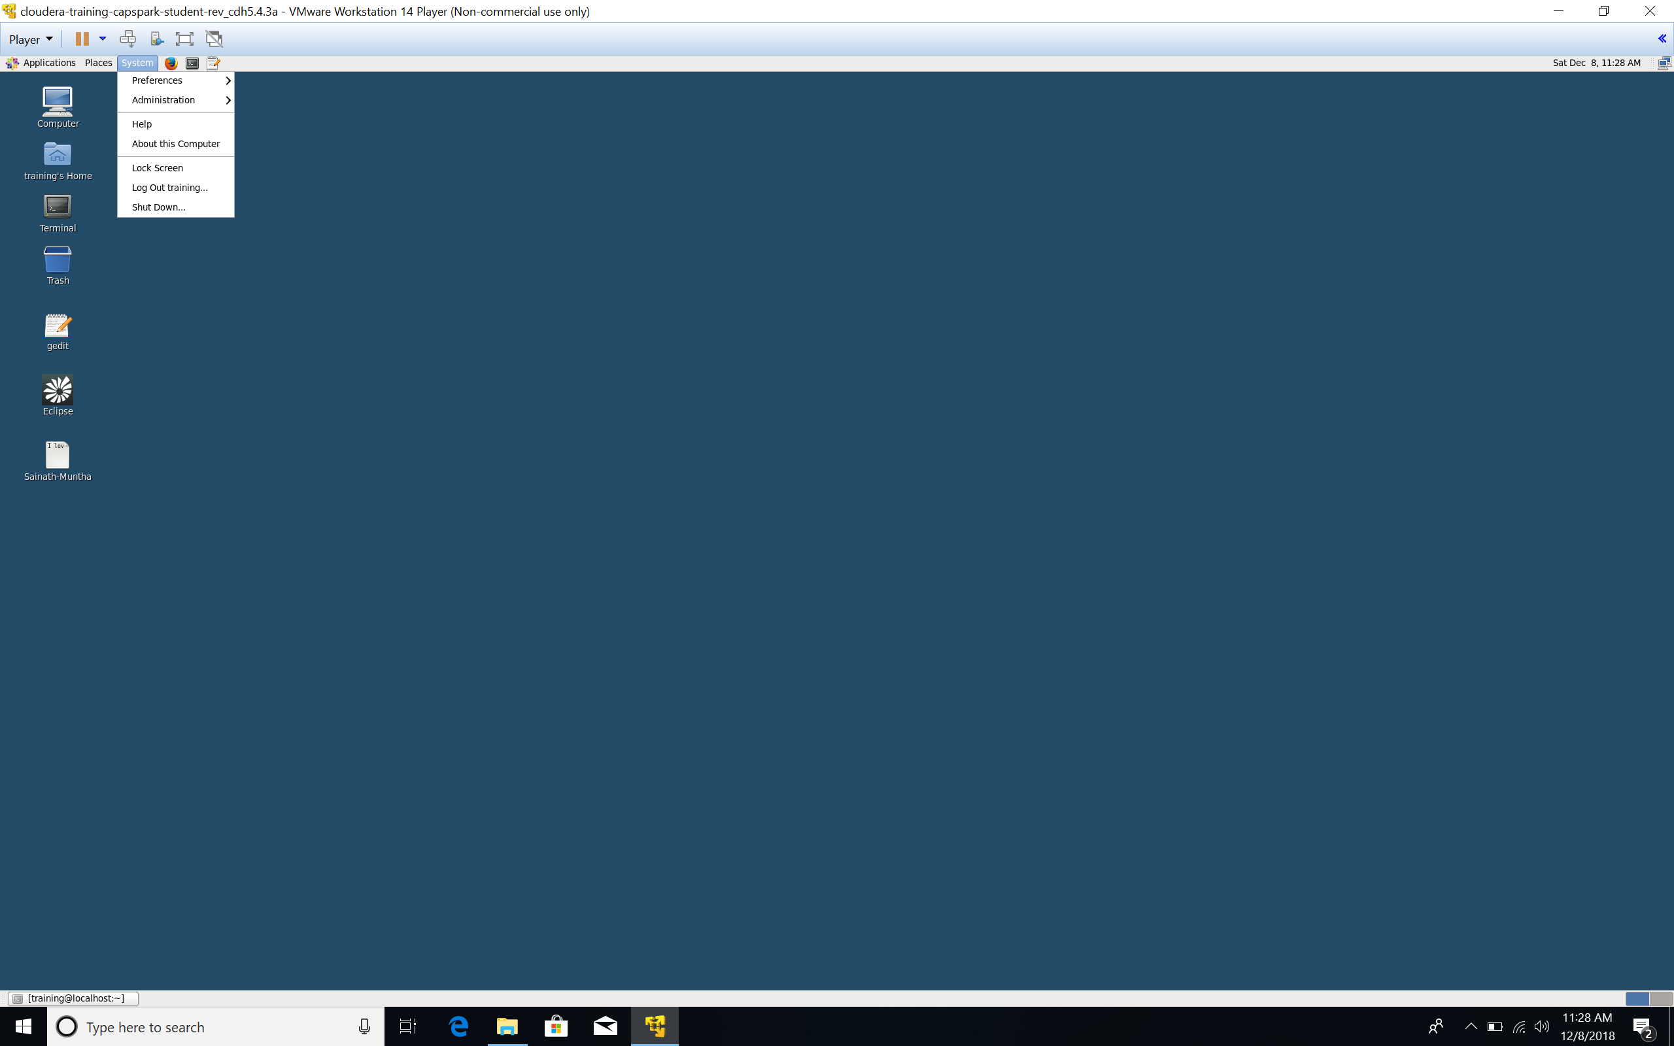

# **ADDITIONAL NOTES:**

* **Do not worry about the meaning of the Linux commands you have used in this assignment so far. They will be explained in detail in the coming assignments.**
* **Please save the user id and password given to you in Step-23. This is your user id and password for the Cloudera VM and any applications you may use in the Cloudera VM.**
* **The main directory for the homework when using the Cloudera VM is $DEV1/exercises.**